**AWS Cloud9 Setup**

1. Create a Cloud9 instance:
2. Launch Cloud9 in us-east-1 for this workshop: <https://us-east-1.console.aws.amazon.com/cloud9/home?region=us-east-1>, or choose any other AWS region based on your convenience.
3. Select Create environment
4. Name the environment ‘<*cloud9-cdk-environment>*’, and click Next
5. Choose ‘*t3.small’* for instance type, take all default values and click Next
6. Review Environment name and settings then click ‘*Create environment’.*
7. Create an IAM role for the Cloud9 instance with least privilege access:
8. Create an IAM Role
9. Confirm that AWS service and EC2 are selected, then click Next to view permissions.
10. Attach necessary IAM permissions, then click Next: Tags to assign tags.
11. Take the defaults, and click Next: Review to review.
12. Enter ‘<*cloud9-cdk-environmen-iam-role>’* for the Name, and click Create role.
13. Attach the created IAM role from Step B to your Cloud9 instance:
14. Navigate to the EC2 Console to find your Cloud9 EC2 instance.
15. Select the instance, then choose Actions / Security / Modify IAM role  
    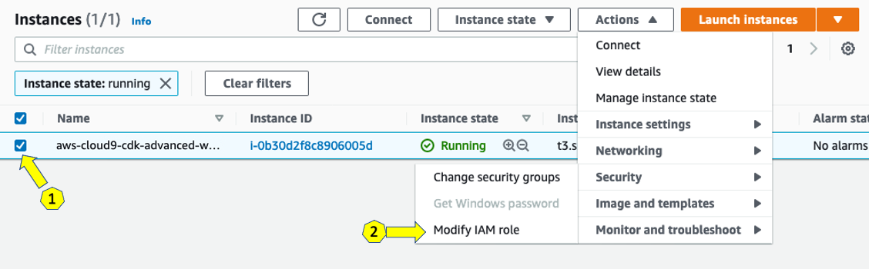
16. Choose *‘<cloud9-cdk-environmen-iam-role>*’ from the IAM Role drop down, and select Apply
17. Update your Cloud9 IAM settings:
18. Return to your workspace and click the gear icon (in top right corner), or click to open a new tab and choose “*Open Preferences*”
19. Select *‘AWS SETTINGS’*
20. Turn off ‘*AWS managed temporary credentials’*
21. Close the Preferences tab  
    Graphical user interface, text, application

    Description automatically generated
22. AWS Configurations:
23. To ensure temporary credentials aren’t already in place we will also remove any existing credentials file:  
      
    rm -vf ${HOME}/.aws/credentials
24. Install jq  
      
    sudo yum install jq -y
25. Configure AWS CLI with our current region as default.  
      
    export ACCOUNT_ID=$(aws sts get-caller-identity --output text --query Account)  
    export AWS_REGION=$(curl -s 169.254.169.254/latest/dynamic/instance-identity/document | jq -r '.region')
26. Check if AWS_REGION is set to desired region  
      
    test -n "$AWS_REGION" && echo AWS_REGION is "$AWS_REGION" || echo AWS_REGION is not set
27. Save these into bash_profile:  
      
    echo "export ACCOUNT_ID=${ACCOUNT_ID}" | tee -a ~/.bash_profile  
    echo "export AWS_REGION=${AWS_REGION}" | tee -a ~/.bash_profile  
    aws configure set default.region ${AWS_REGION}  
    aws configure get default.region
28. Validate the IAM role  
      
    aws sts get-caller-identity --query Arn | grep *cloud9-cdk-environmen-iam-role* -q && echo "IAM role valid" || echo "IAM role NOT valid"